WHANGANUI BAY MAORI RESERVATION TRUST

PAPAKAINGA O NGĀTI TE MAUNGA

POLICY NAME: INTERPRETING THE TRUST GAZETTE NOTICE | POLICY NUMBER: P017
ORIGINAL AUTHORISATION: Chairperson | DATE: Jun 2018

Version Control:
Serial | Date | Change | Responsible | Sign

Associated policies: The associated policies include:
- Maori Reservation Act.
- Whanganui Bay Maori Reservation Charter P001.

Aim
- The aim of this policy to highlight how the Gazette Notice for Whanganui Bay Maori Reservation is to be interpreted to ensure that the interests of Ngāti Te Maunga are protected has the hapū who has Mana-Whenua over Hauhungaroa Blocks.

Gazette Notices
- The two Gazette Notices are the Deed of Trust for the Whanganui Bay Maori Reservation Trust. The first notice was published in 1969 and a second notice was published in 1985. The second being published to primarily notify of the additional land that was placed into the Reservation.

Interpretation
- The following interpretations are applied to the Notices:

  - Burial ground refers to Urupa.
  - Meeting place refers to traditional based and Ngāti Te Maunga hapū based meeting that have been approved. Furthermore these meeting are to be approved by the Trust. These meeting are normally to be held in the Wharepuni, Wharekai or Whare Wānanga.
  - A place of historic interest and scenic interest this refers to the history of Ngāti Te Maunga and scenic interest as determined by Ngāti Te Maunga.
  - Community Centre refers to the Whanganui Bay marae and its traditional management and use.
  - Common use and benefits of members of Ngāti Tūwharetoa tribe and members of Ngāti Te Maunga subtribe in particular – this phrase is interpreted as follows:
    - Members of Ngāti Tūwharetoa may visit Whanganui Bay without prior written permission for the purposes of tangihana and unveiling.
    - Members of Ngāti Tūwhareota may visit Whanganui Bay for traditional maori cultural events and activities as approved by the Trust.
    - Members of Ngāti Te Maunga, as the people who have mana-whenua over the land have the greatest rights and access to Whanganui Bay and these are exercised and managed through the Trust and tino rangatiratanga and mana motuhake of the hapū.
    - The Trust Charter and policies should be referred to further to understand the extent of various access, activities and management within Whanganui Bay.

- The 1969 Notice:
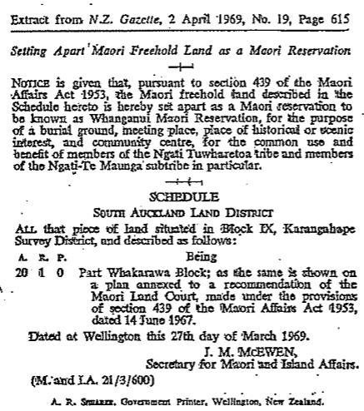

- The 1985 Notice:

